**SSN Screenshots**

*There are three screenshots included, you may need to scroll down. I have made this file a docx if you need to enlarge the image size.

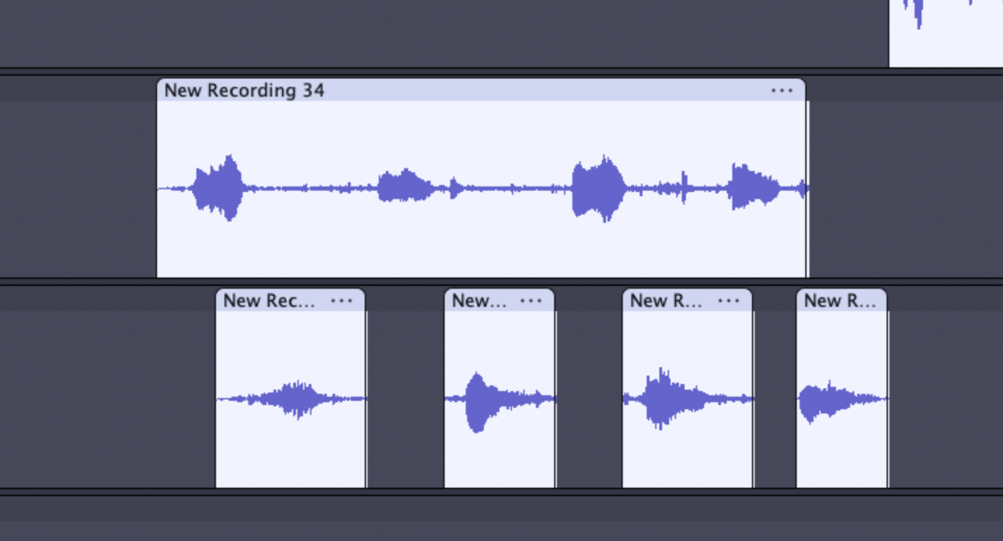

This is the part of the story where the squirrel is taking Billy through a breathing exercise. The long audio clip is the squirrel and the split clips are Billy breathing in and out. This was the most difficult part of the project to edit because I needed to be very precise about where each clip was so that Billy’s responses were timed perfectly to respond to the squirrel’s commands. Because all of these clips were originally part of one long audio clip they had to be separated and each clip needed to be individually pitched up according to the needs of the character.

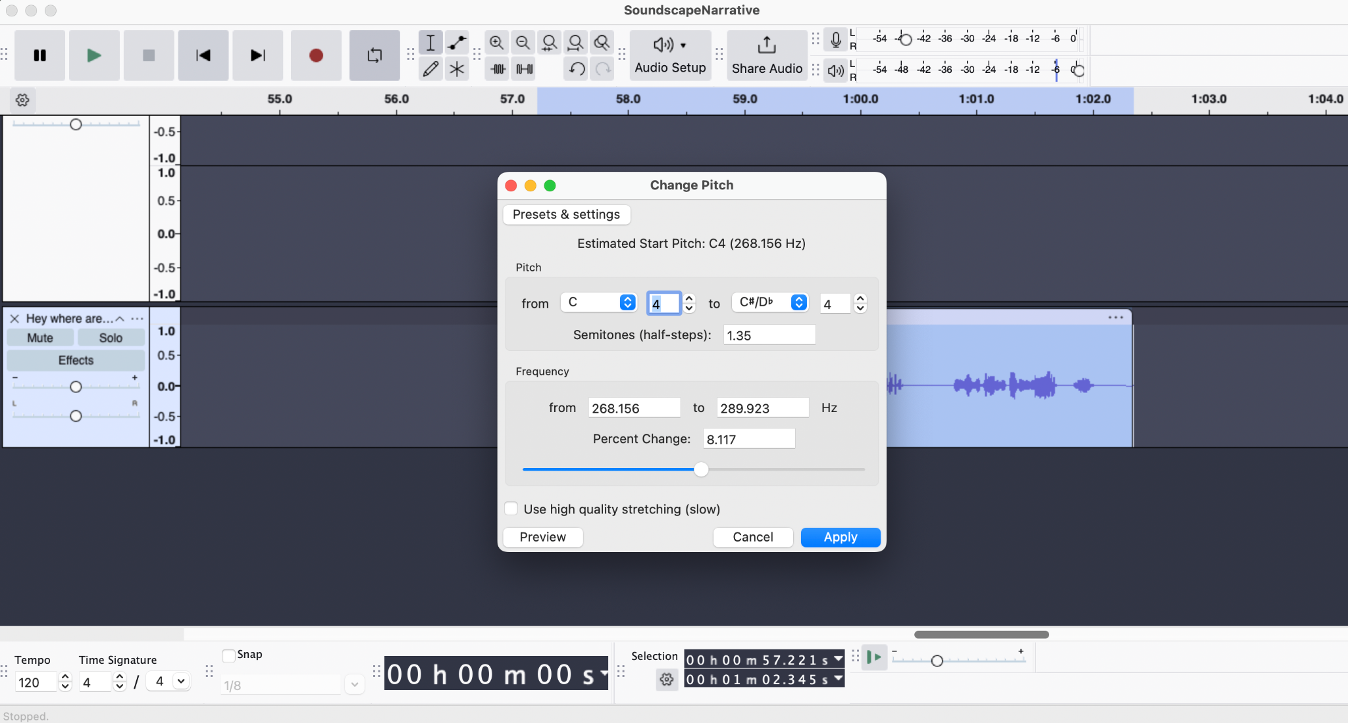

This screenshot captures me pitching up Billy’s voice. Pitching up the squirrel’s voice was much more challenging because it was the first voice I changed the pitch of and it had to be much higher than a regular voice. I discovered that percent change is the best way to easily pitch up a voice rather than playing with the semitones. Billy’s voice, as you can see, was changed by about 8% but the squirrel’s voice was changed by about 30%. The issue with changing a voice that much was that during my first attempts, the voice became so distorted it sounded like a robot’s. I lowered the percentage a bit which seemed to help.

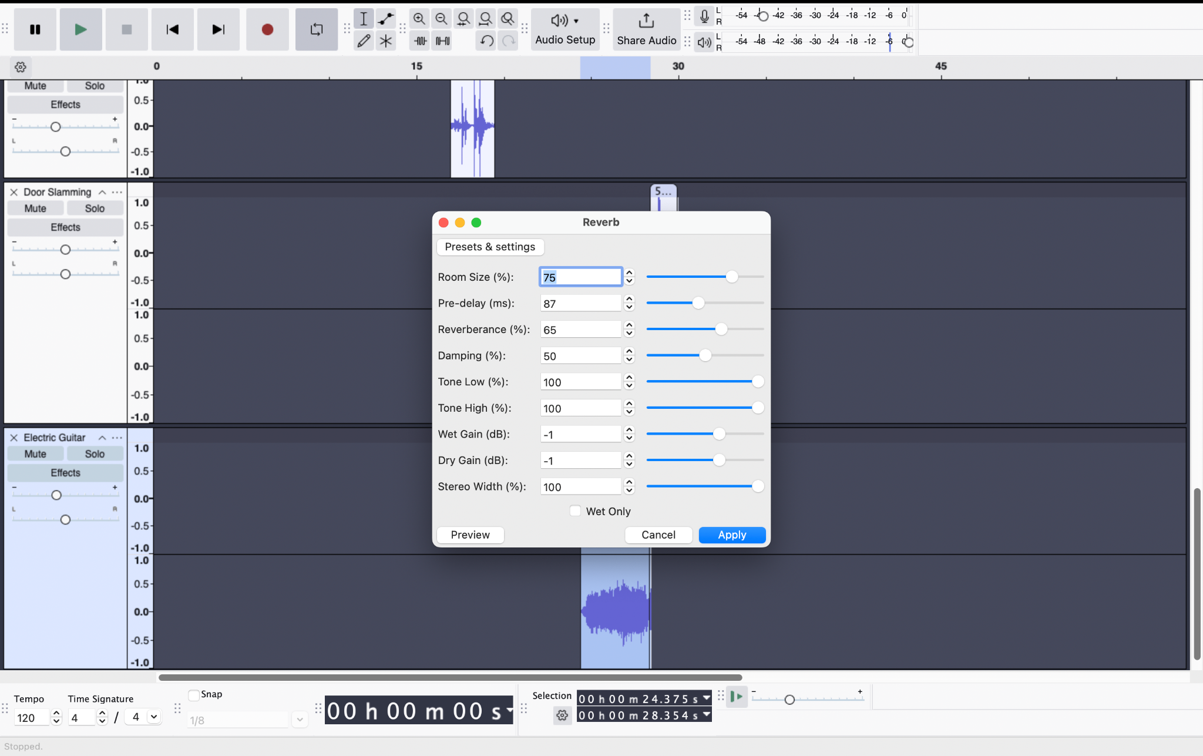

This is the part of the project where I was changing the reverb effect on the electric guitar sound. I initially had no idea what any of these different options meant so I looked up what some of the different options meant and then I played with them a bit. I discovered that a combination of increasing reverberance and pre-delay gave me the desired deep echoey sound.